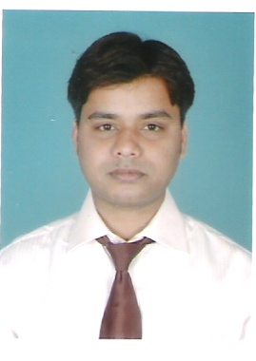
MANISH KUMAR
S/o INDRAJIT SINGH
South Chandmari Road, Kankarbagh
Patna:-800020
9711867545, 9934878348
Manishkumar1129@gmail.com

Objective:-A position in financial sector where my analytical and technical skills can help to improve company’s profitability.
Career summary:
- Worked with “MARGDARSHAK” educational consultancy
Key responsibility area:
- Give career guidance to the clients (students).
- Manage operations, including funds &advertisement.
- Work to increase clientele.
- Arrange meetings with institution’s authorities.
- Look after office operations.
2. Summer training project details:-
Worked with HDFC SLIC Patna for 8 week
Key responsibility area:
- Tracking of prospective customers.
- Taking prior appointments to meet the customers.
- Taking notes about the customers requirement about the insurance policy.
- Giving them complete details about HDFC SLIC’S LIFE INSURANCE POLICIES.
- Follow up with the interested customer.

Other accomplishments:

- Attended executive workshop for “MASTERING THE ROCKEFELLER HABBITS” by
“Mr. Verne Harnish”.
- Prepared research report on “ISLAMIC BANKING” under the supervision of international college of financial planning.
ACADEMIA:
- Pursuant of Post graduate diploma in “Security analysis & trading( PGDSAT) from
“International college of financial planning” (ICOFP) promoted by “BAJAJ CAPITAL LTD.
- Bachelor’s in English from Magadh University.
- I.S.C. from Bihar intermediate education council (B.I.E.C.).
- Matriculation from Bihar school examination board (B.S.E.B.).
Computer proficiency:

- Savvy with ms word.
- Knowledge about Ms excels charts, graphs, & tables.
- Made some power point presentations in college.
- Knowledge about capital line software.
Professionals Certification’s:
- Capital market Dealer’s module
- Derivative market Dealer’s module

Date of birth:-12.02.1985
Father’s name: - INDRAJIT SINGH

S/O INDRAJIT SINGH
South chandmari road, kanakarbagh
Patna:-800020
9711867545, 9934878348
Manishkumar1129@gmail.com Signature: - MANISH KUMAR

